**Introduction**

For this project, you will act as a data researcher for the World Health Organization. You will investigate if there is a strong correlation between the economic output of a country and the life expectancy of its citizens.

During this project, you will analyze, prepare, and plot data, and seek to answer questions in a meaningful way.

After you perform analysis, you’ll be creating an article with your visualizations to be featured in the fictional “Time Magazine”.

**Focusing Questions** :

* Has life expectancy increased over time in the six nations?
* Has GDP increased over time in the six nations?
* Is there a correlation between GDP and life expectancy of a country?
* What is the average life expactancy in these nations?
* What is the distribution of that life expectancy?

GDP Source:[World Bank 4](https://data.worldbank.org/indicator/NY.GDP.MKTP.CD)national accounts data, and OECD National Accounts data files.

**Scatter Plots of GDP and Life Expectancy Data**

To create a visualization that will make it easier to see the possible correlation between GDP and life expectancy, you can plot each set of data on its own subplot, on a shared figure.

[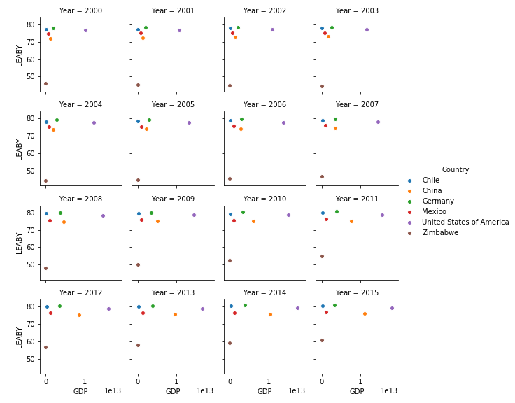](https://aws1.discourse-cdn.com/codecademy/original/5X/5/f/6/5/5f658c36568453ec6e488d2fc2ab02b50efea17c.png)